Length
Length is the distance between two points as is measured in meters. We use length to compare many objects and distances.
An object can have several measurements of lengths (we call these “length, width”, and “height”).
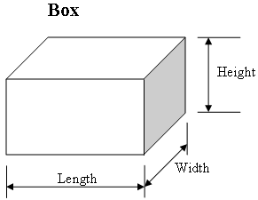

- Find the length of each object on your tray except the tissue box. Record this information by writing the name of the object with its largest measurement of length written next to the name. Don’t forget to include the units!
Example: Pencil 30cm

- If the object is a cube, we can use math to find the volume of the object. Find the volume of the tissue box by multiplying the length x the width x the height.
(Length of box: _____) X (Width of box: ______) X (Height of box: ____) = (Volume: _______)

Volume
The volume is the measure of the amount of space an object takes up, and can be measured with a beaker (mL or L), solved mathematically (Length X Width X Height), or by using the displacement method.
Volume is measured in a beaker by reading the meniscus (the curve of the water) at eye level.

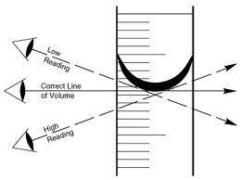

- Find the volume of the liquid in each beaker. Don’t forget units!
Red liquid: ______
Blue liquid: ______
Green liquid: _____

- Use the displacement method to find the volume of the marble. Record. Don’t forget units!

The volume of the marble is: _____.

*** Hint: Fill the empty beaker up to 25 mL. Next, drop the marble into the water in the beaker. Record the new measurement. Subtract the old measurement (water only) from the new measurement (water + marble). This will equal the volume of the marble only, since you have subtracted out the water you started with.
Mass
Mass is the measure of the amount of matter (everything is made of a physical material called “matter”) in an object, and is recorded in grams.

Mass can be found either on a triple beam balance or on an electronic balance.

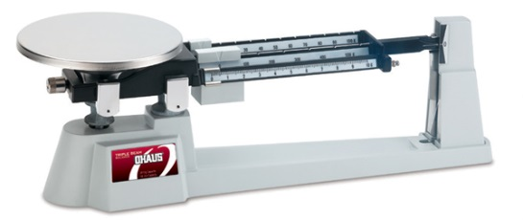

- Use the triple beam balance to find the mass of each object in the plastic box. Record this information by writing the name of the object with its measurement of mass written next to the name. Don’t forget to include the units!
Example: Pencil 30 grams

Density
Density is the measurement of how close matter in an object is (how compact the matter is). Density is found by dividing the mass by the volume (mass/volume) or (g/cm³).

- A. Find the mass of the penny on the electric balance. Record.

B. Find the volume of the penny using the water displacement method. Fill the empty beaker up to 25 mL. Next, drop the penny into the beaker of water. Record the new measurement. Subtract the old measurement (water only, 25 mL) from the new measurement (water + penny). This will equal the volume of the penny only, since you have subtracted out the water you started with. Record this measurement.
C. Use a calculator to divide the mass of the penny by the volume of the penny. Record this final measurement as “Density of Penny = _____ g / mL”

- Compare the density of the penny that you found in #6 to the density of water, which is:

Density of Water = 1 g / mL

Write out your comparison using a complete sentence.

