How Do Planets Form?
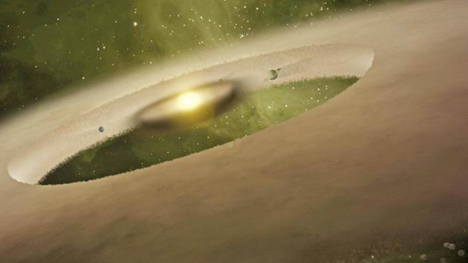NASA: JPL-Caltech: Corbis
Artist's conception of planets forming around a sun-like star.
9/7/14 By Robinson Meyer of The Atlantic

In the past half-decade, we’ve learned about thousands of planets throughout the galaxy, but we still don’t really know what turns young, spinning baby stars into stable solar systems. In fact, scientists hold two conflicting theories of planetary formation. In one, the enormous discs that surround baby stars collide and accrete into planet-sized objects; in the other, gravitational instabilities in a star’s surrounding nebula cause new planets to clump their way into existence.
But these theoretical efforts are hampered by a real limitation: We don’t have many examples of baby planets to look at.
An international team of astrophysicists is helping to change that. On Thursday, the researchers announced evidence of a second planet orbiting HD100546, a still-young star much larger than our sun. The baby planet seems to be a gas giant, and it orbits its star a little farther than Saturn orbits ours.
This is the second proto-planet that Brittain’s team discovered orbiting HD100546. They detected the first, also a gas giant, last year, which marked “the first time [we saw] a planet forming inside its natal environment.”

“This system is very close to Earth, relative to other disk systems,” said Clemson University astrophysics professor Sean Brittain, a leader of the research, in a release. “We’re able to study it at a level of detail that you can’t do with more distant stars. This is the first system where we’ve been able to do this.”
“Twenty years ago, we didn’t know if we were the only solar system in the galaxy,” Emily Lakdawalla tells me. Lakdawalla is a geologist and senior editor of the Planetary Society and was not connected to the new study. “But now we have these thousands of exoplanetary systems.”
Many people, Lakdawalla said, want to know if exoplanetary research is locating additional Earths. But peering at other systems is useful beyond looking for extraterrestrial life: It lets us “understand how our own solar system came to be."
“By studying other exoplanetary systems, we can help decide whether our theories about our own solar system are correct or not,” Lakdawalla said.
Which the system around HD100546 may not let us do quite yet. Though it’s one of precious few examples of observed proto-planetary systems, the study’s evidence might not be useful for advocates of either competing planetary-formation theory.
“Unfortunately, from what I read in this paper, these observations don't really shed light on which of these two theories might be right,” said Amy Barr Mlinar, a planetary scientist and associate professor at Brown, in an email.
She added: “This paper does shed light on some issues such as the structure of the protoplanetary disk (how much gas is there and where the gas is) and how gas flows from the protoplanetary disk onto the growing planet. These are things that theorists can model on a computer but this may be one of the most detailed observations of this process.”
To Lakdawalla, one of the most exciting aspects of the study was evidence of a disc around the newly-discovered planet itself. That makes these new gas giants look even more like our own: Jupiter, Saturn, Neptune, and Uranus all sport a ring or ring system.

The Clemson team used two observatories, the European Southern and the Gemini, to observe HD100546, then they analyzed individual wave forms to detect the presence of certain chemicals. Specifically, they looked for carbon monoxide and hydroxide, a form of water that has had one of its hydrogen atoms blasted away by the sun.

Lakdawalla compared the actual experience of finding the planets to looking for a gap. “It’s like,” she said, “looking at Saturn’s rings and seeing a gap and wondering if there’s a moon there.”
Such a technique has been used successfully before, in fact. When Voyager 1 flew by Saturn in 1980, it photographed dark spots in the planet’s rings. Some of these gaps turned out to be moons.

More baby solar systems are likely to be found in the next few years. In the past half-decade, our understanding of exoplanets has ballooned—thanks in part to Kepler, theNASA spacecraft that has located almost 1,000 planets outside our solar system. In November, a researcher at the University of California announced that Kepler data indicated that there could be as many as 40 billion Earth-like planets in the Milky Way galaxy alone.

